Thesis: Coffee prices to appreciate
Last Update: February 8, 2020

Coffee Prices to rise ↑ | Coffee prices, as measured by Arabica beans traded on ICE, have fallen sharply since 2011. Prices, at $0.95/lb., are considered below production costs. Consequently, farmers have voluntarily switched to other crops or shut-down. Once the Brazilian real stabilizes, pricing could be expected to firm as demand growth continues. Demand growth is temporarily weak due to the Coronavirus disease in China

Overview:
Legend has it that coffee was discovered by a goat herder in the Kaffa region of Ethiopia, who noticed his goats grew rather jumpy after nibbling on the plant. It is believed that the coffee beverage was developed in the Yemeni city of Mocha circa 1400. September 2019: New data from the Aug’19 ICO (Intl Coffee Org) shows that while demand has been as predicted, supplies doubled earlier expectations. Hence, the S/D balance is a surplus of 5 million bags.
February 2020: Prices rose sharply (+35%) during 4Q’19 due to unfavorable weather and a sudden change in supply/demand balance. Latest readings from the ICO show a 0.6 million bag deficit for the 2019/20 season. However, prices started plunging in early 2020, mostly attributed to Coronavirus in China and profit taking.

Coffee rises | Coffee declines
- Brazilian coffee production is expected to have an “off year” in 2019/20 (thus lower yields per hectare). In fact, the S/D balance is now at a 0.6 million deficit | - Large low-cost Brazilian factory farms are increasing production and market share. These farms are profitable at prices below $1.00/lb.
- The Brazilian government is undergoing reform of the economic system which should eventually boost the economy and its currency. | - Brazilian real (and other EMK currencies) is declining (lowering production cost). Contagion risk in South America (Argentina, Venezuela…)
- The high proportion of large-scale industrial farming in Brazil leaving a large percentage of crop subject to climate change and disease (the plants are sensitive) | - Sentiment shifted from Negative to Positive in terms of Commitment of Traders reports (contrarian indicator)
- Long term demand growth remains positive in the 1.5%-2.5% range. Coffee increasing share in China which is attributable to the rising middle class. | - Much of the incremental growth is from China which is reducing coffee demand due to Coronavirus. The demand drop appears cyclical, not secular.
- Farmers are switching to other crops including illegal plantings. | - Futures market is in Contango, an investment could result in losses even if the spot price remains flat.
- Retailers/Roasters such as Nestle may be forced to solve the farm-gate issue of ultralow prices (versus high prices ($3-$4/cup) on the retail end. | - The only available ETF is structured as an exchange traded note (counterparty risk with Barclays).

Heat Map legend

Strongly +
Strongly -

Coffee Prices (last decade)
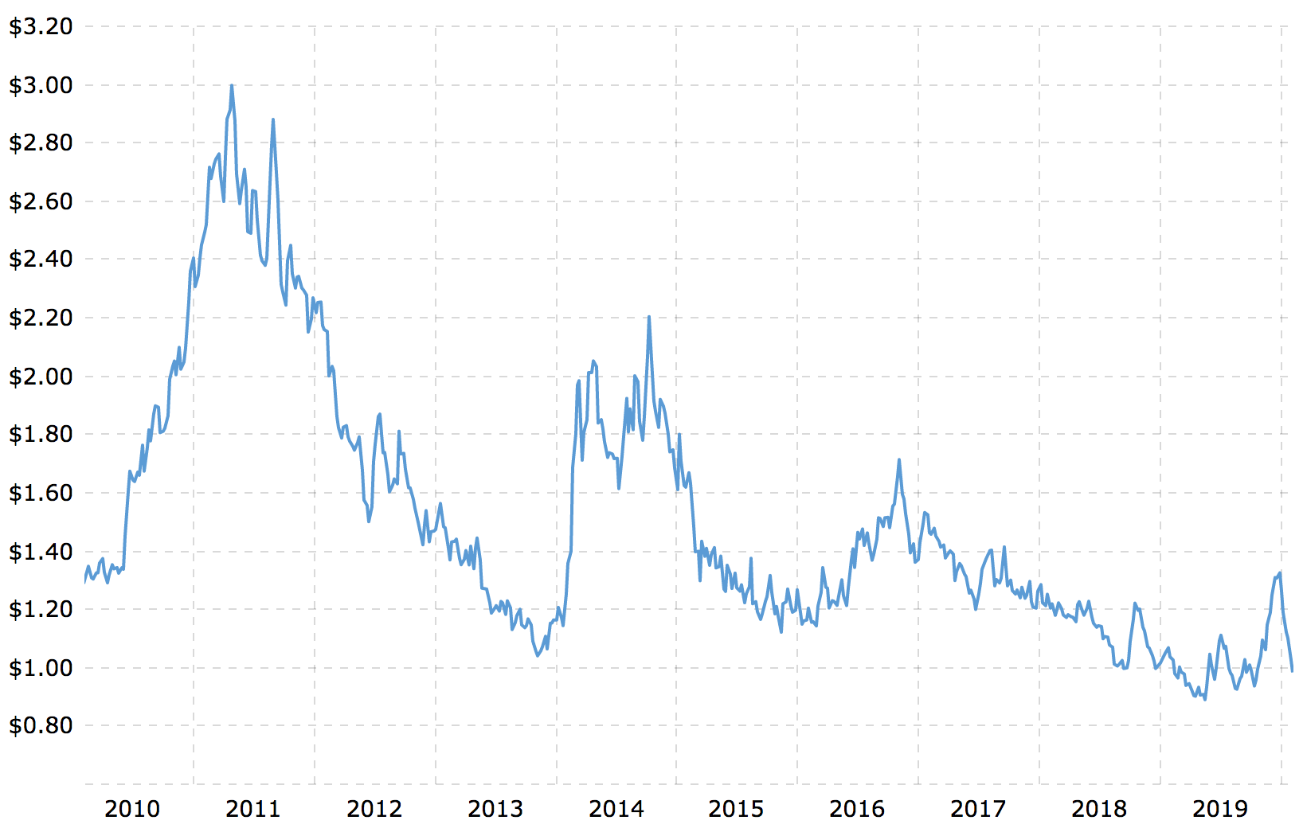

Notes:
- Additional sources of information on coffee can be found in: Daily Coffee News, USDA Foreign Agricultural Services, and the International Coffee Organization.

ETFs/Futures:
Ticker | Name | Comments
JO | iPath Bloomberg Coffee Subindex | Fairly liquid, <0.5% expenses, exchange traded note (ETN) and thus counterparty risk with Barclays Bank PLC.
KC  (ICE codes) | Coffee C contract | Contract Size: 37.5k pounds of Arabica coffee, Listed Contracts: Mar, Ma, Ju, Sep, Dec.  https://www.theice.com/products/15

Charts supporting or contradicting the above thesis (charts are retained given the evolution of the data over time)

Commitment of Traders
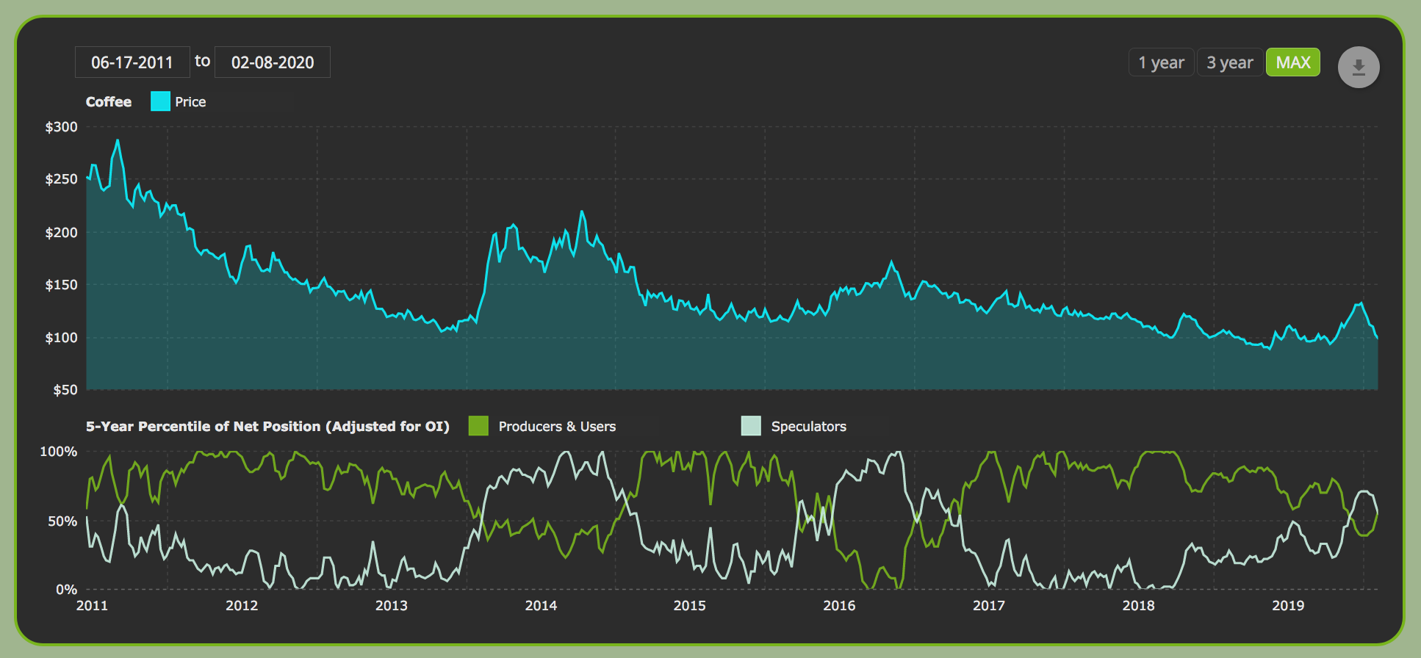

Global Supply/Demand Balance (ICO 1/2020)
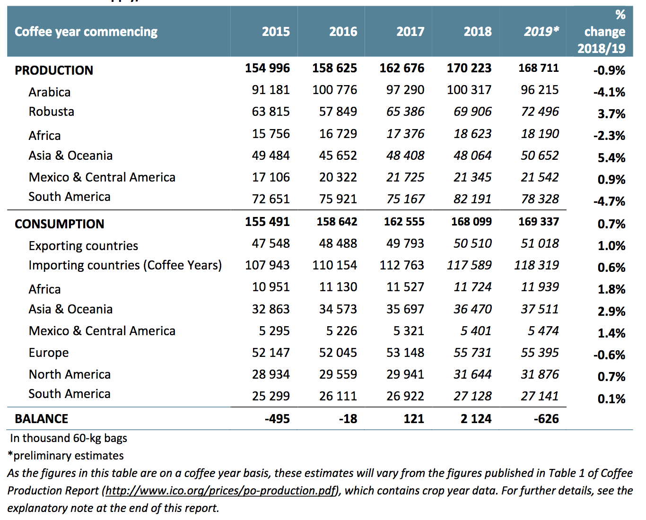

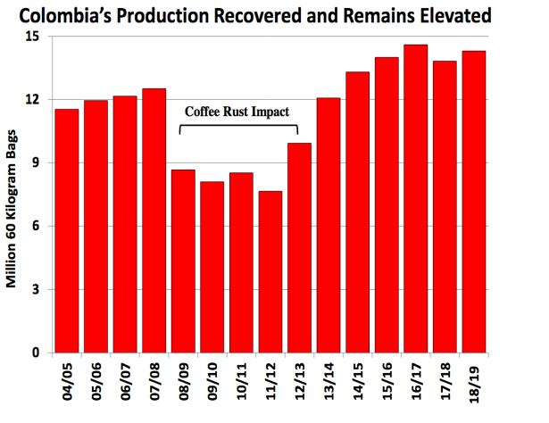

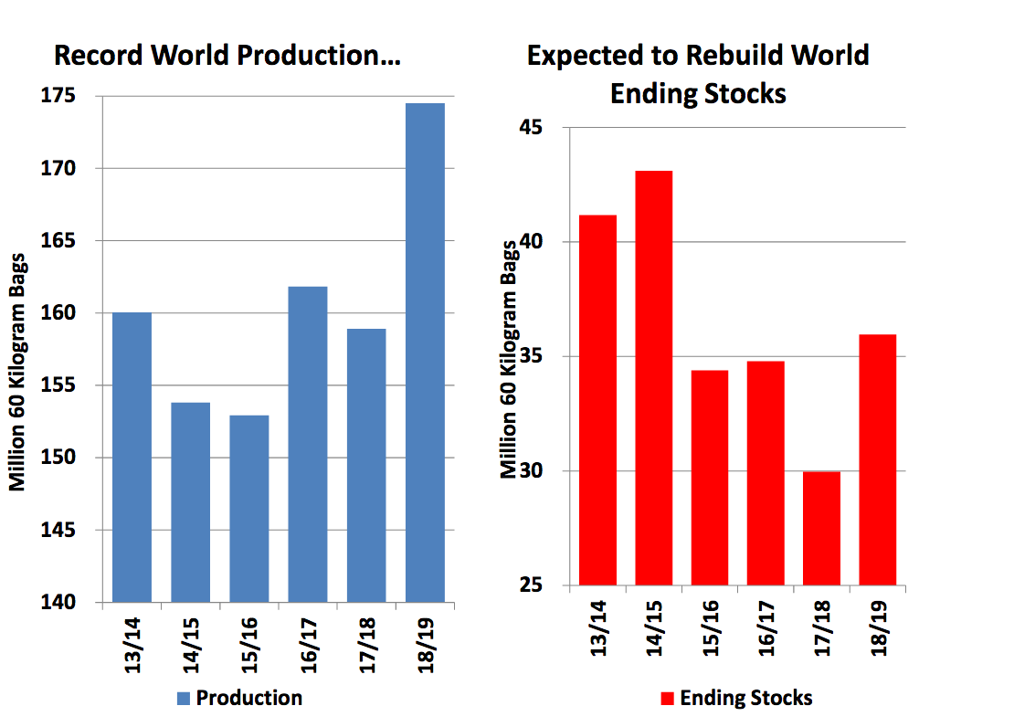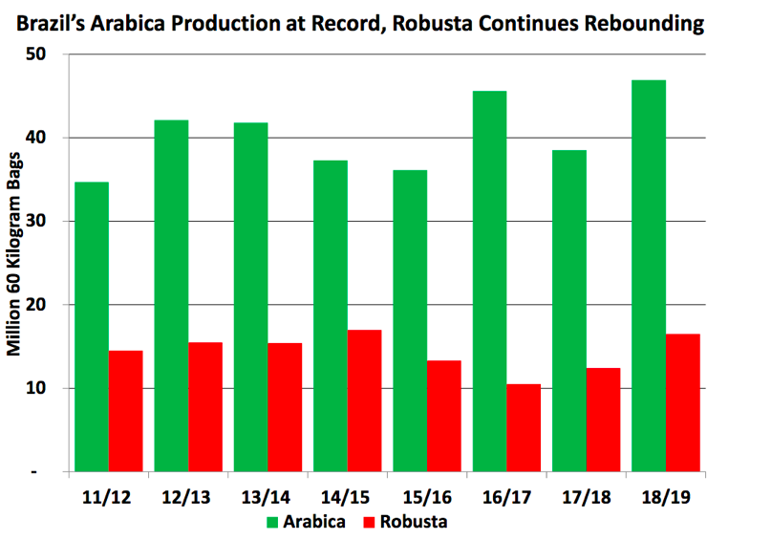
Source: USDA Source: USDA

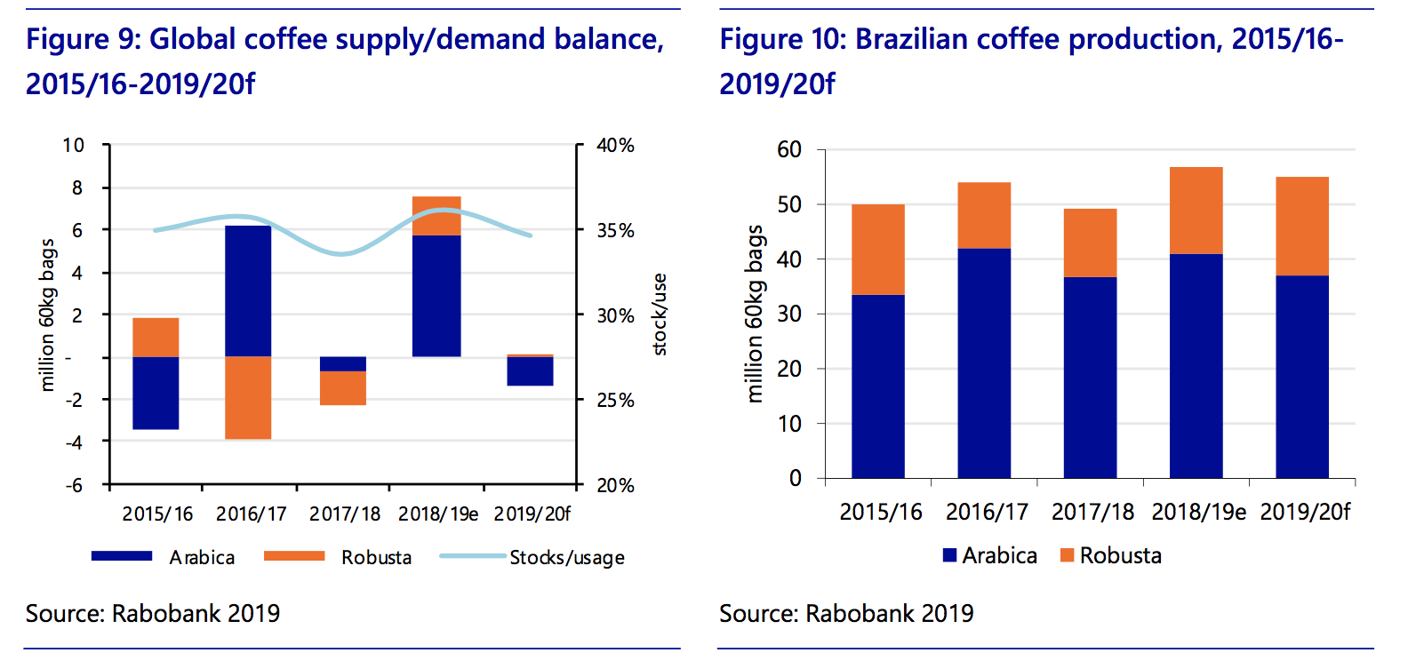

Brazilian Real vs US Dollar Brazil macroeconomic data
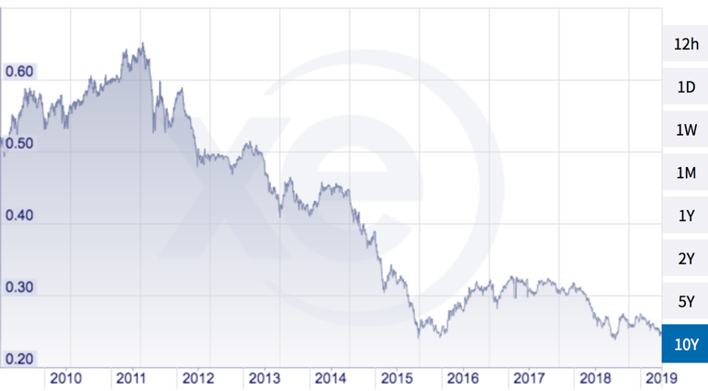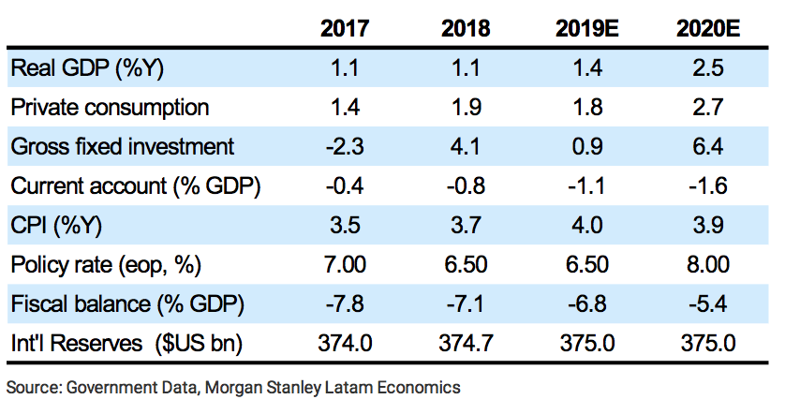

China: End-Market demand, as measured by growth for Luckin Coffee

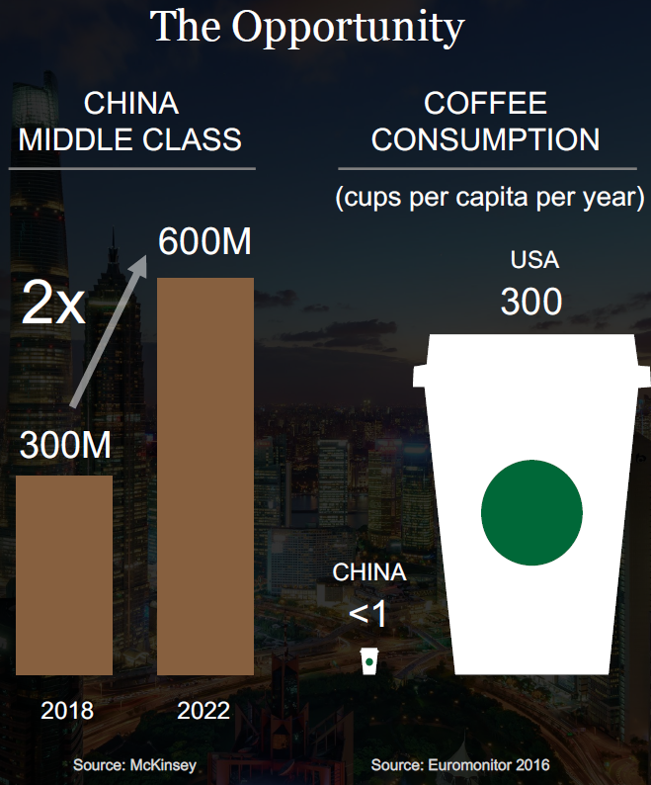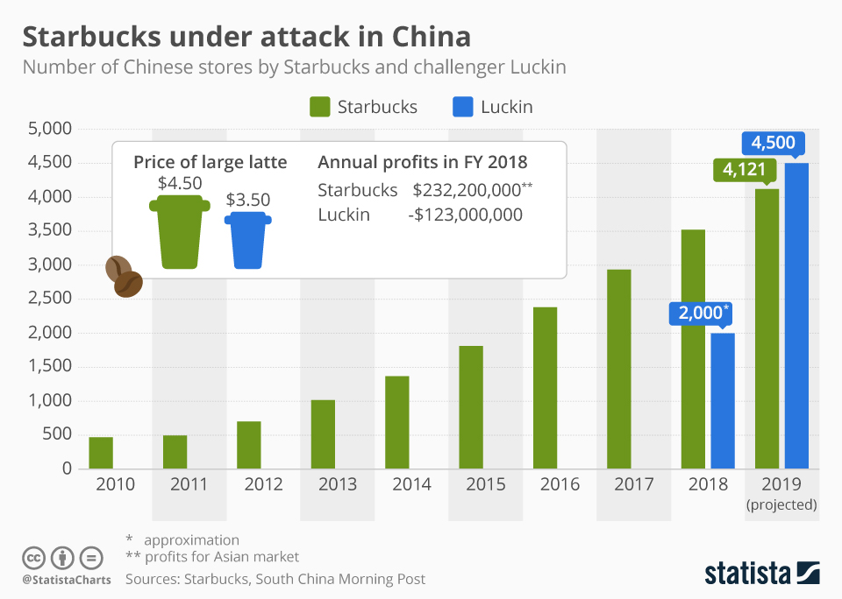

ICO Report as of August 2019

Disclaimer:
You agree that the use of Lombardo Asset Management’s (LAM LLC’s) research and opinions are at your own risk. In no event should LAM be liable for any direct or indirect trading losses caused by any information available on this site. The materials on the site are not an offer to sell or a solicitation of an offer to buy any security, nor shall any security be offered or sold to any person, in any jurisdiction in which such offer would be unlawful under the securities laws of such jurisdiction. LAM makes no representations, and specifically disclaims all warranties, express, implied, or statutory, regarding the accuracy, timeliness, or completeness of any material contained in this site. The principals of LAM LLC may hold a position in any of the securities cited on this website.

