**The Heresy called WeWork**

*“On the sixth day, God created Adam in the garden of We-Eden.”*

I focus on [socially responsible investing](https://en.wikipedia.org/wiki/Socially_responsible_investing), screening for companies that are environmental stewards, treat their employees well and have organizational systems that ensure good governance (meaning there are checks and balances).

[WeWork](https://www.wework.com/mission) - officially called The We Company (WE) in particular, excited me given its strong [mission](https://www.wework.com/mission), culture and framing as a service-tech company and its veggie-friendly hospitality. The company rents the best designed hipster workspaces I’ve ever seen to freelancers, startups, and increasingly, enterprise businesses.

I also [rate](http://lombardoassetmanagement.org/category/equities-long/) initial public offerings (IPOs) presenting the ratings in the form of a Heat Map utilizing ten criteria. [See link to excel file](http://lombardoassetmanagement.org/category/equities-long/). The table includes recent IPOs, such as highest rated Zoom Video (ZM), as well as Snap (SNAP) which is considered *the* unsuccessful IPO. Though, I believe WeWork may prove to be the worst of them.

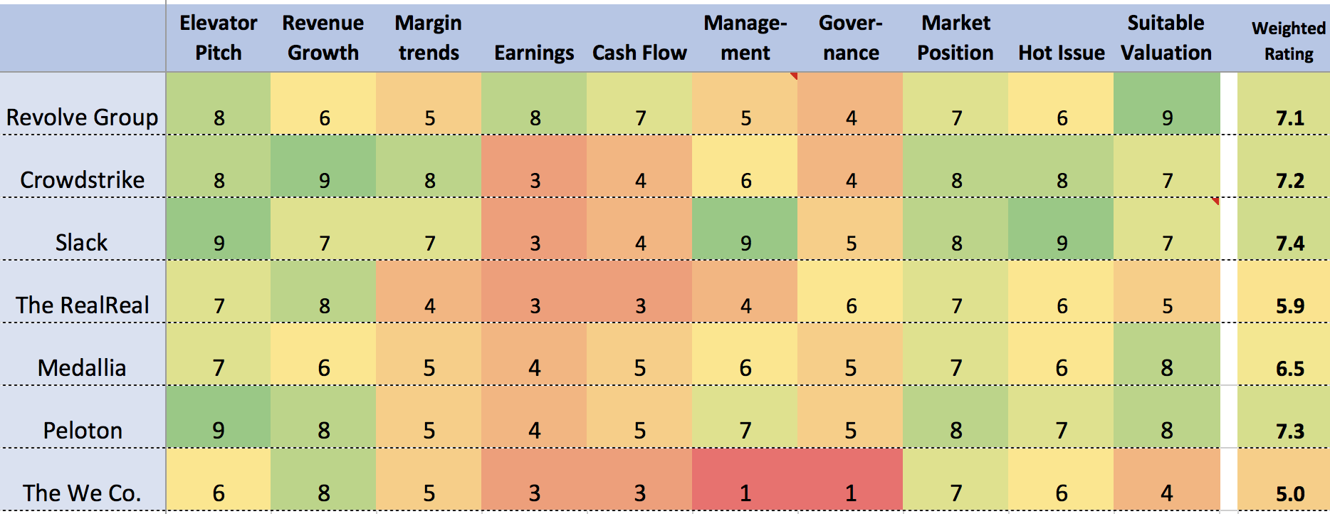

Source: LAM, LLC

As an analyst who gives ESG factors heavier weight, I believe WeWork is a failure before launch. Its **“Gov-lite”** structure raises several red flags. There is a disparity in how the company presents itself and how it governs. I call this “the heresy of WeWork.” This report is divided into four sections: I) Glassdoor reviews, II) Governance, III) Financial highlights and IV) Valuation.

**Section I: Glassdoor reviews**

[Glassdoor](https://www.glassdoor.com/Reviews/index.htm) is a website that allows employees to anonymously post reviews. Glassdoor ratings are from 1 (worst) to 5 (best). Zoom Video (ZM) for example, is rated 4.8 with 97% approving of the CEO. Zoom is absolutely obsessed with everyone being happy. Though that sounds cultish, it’s simply a well-run organization.

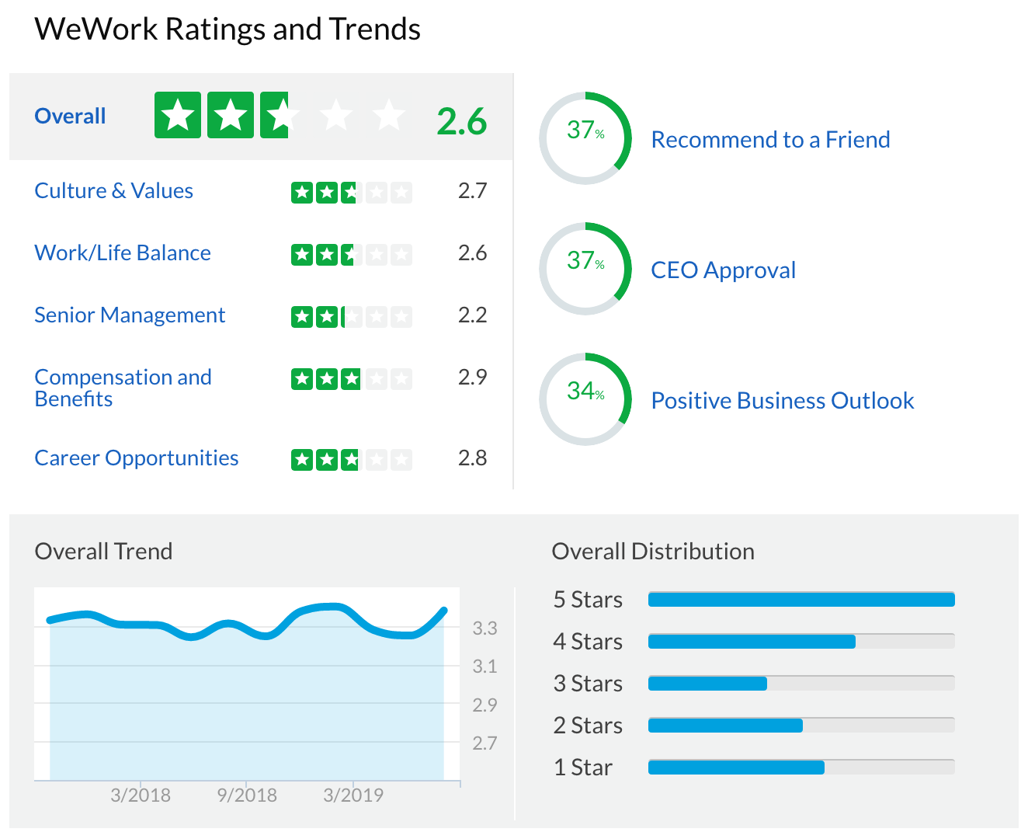

In comparison, WeWork’s overall rating was 3.4 (633 reviews) and if one filters down only to NYC (its headquarters) the rating declines to just 2.6 (157 reviews). **Of those, just 37% approve of the CEO**. These are some of the lowest ratings I have ever seen for an upcoming IPO where there’s excitement in the air. Review highlights are below (note they have not been verified):

* Many employees (especially young singles) like the work setup, free drinks, and extracurricular activities as well as opportunities to change roles given the company’s rapid growth and high turnover rate.
* **Several reviews said WeWork was a cult** and Adam was its leader. I thought that was extreme and looked up the word in [Urban Dictionary](https://www.urbandictionary.com/define.php?term=Cult). “A group, often times though not always religious or spiritual in nature, that is led by a single or small group of leaders…” Adam’s name appears 169 times in the [S-1 filing](https://www.sec.gov/Archives/edgar/data/1533523/000119312519236798/d781982ds1a.htm) with the SEC. That is far more than the average IPO and more than double (79) of Snap’s Evan Spiegel. The usually boilerplate S-1 is filled with unworldly language such as “We dedicate this to the energy of We…” –in fact the word “energy” is repeated 13 times and the word “inspire” 11 times. Adam speaks of everyone having “superpowers”.
* **Paranoid, incompetent and unpredictable upper management**. The source of this seems to be that management are friends and family (nepotism) of Adam. Employees live in a state of constant fear of being fired given that Adam likes to fire 20% of employees every six months to keep everyone “on their toes.” One reviewer describes it as a Game of Thrones. Pay was described as uncompetitive with little upward mobility. Several reviewers noted flaws and errors that were overlooked (internal control issue?). The work environment was described as chaotic, unpredictable, disorganized, with non-existent work-life balance which is hypocritical of its mission of “make a life, not a living.”
* **A male frat-like environment that supports sexual aggression, sex discrimination, and discrimination based on age and race**. Several reviewers gave personal accounts of the above. Some said there were [several allegations](https://www.fastcompany.com/90367486/wework-is-being-sued-for-age-and-gender-discrimination) which the company denied despite having witnesses. Employees are forced to settle via arbitration agreements.
* Mandatory team building events such as Thank God It’s Monday (held for hours **after** 5pm) and the **“bunga-bunga” like Summer Camp offsite** were described by some (women) with a sense of dread. They were given lots of alcohol and drugs – food? not so much. One reviewer described it as one step away from Fyre Festival. Reviewers were confused over leadership meetings where people held hands, bared their souls and cried. And one woman dreaded having to share a tent with a male. **Last but certainly not least, some reviewers noted executives were doing drugs at some events**.
* **The company wants WeWork to be the primary focus of your life**. They do that by forcibly building camaraderie through corporate events and you’re expected to send your kids to WeGrow (their school), live at WeLive (housing) and workout at Rise by We (gym). Several noted the company wanted employees to follow policies with no questions asked (such as giving up meat).

**Section II: Governance issues**

There is an ancient saying that “A fish rots from the head down” and this is reflected in governance below.

* **ARK real estate platform**: Adam had owned buildings it was leasing to WeWork which was a conflict of interest. Consequently, ARK was created to purchase Adam’s buildings at cost creating very good “optics”, however, the cure seems worse than the disease. ARK, jokingly named after “Adam, Rebecca and Kids” recalls LJM (named after Enron CFO’s family). ARK is a complicated off balance sheet entity used to purchase buildings that are partially leased to WeWork (so they’re on both sides of the negotiating table). While WeWork has committed just 7% of ARK’s $2.9Bn in capital, note it will retain control via the ARK general partner and ARK manager. This control also implies that WeWork could be responsible for debt of buildings acquired by ARK. While complicated, I believe this factor is the critical weakness of WeWork’s governance.

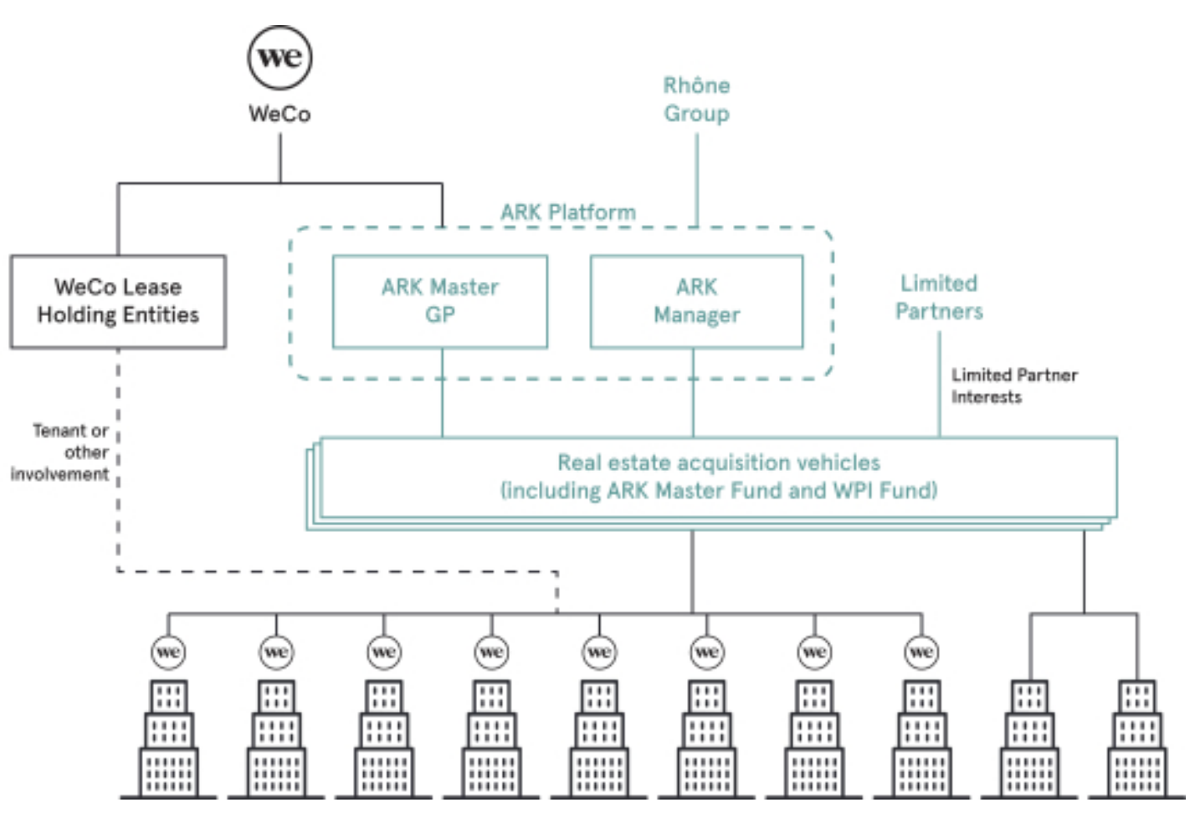

* **Adam’s supervoting shares** under a dual-class voting structure weakens shareholder protection as well as oversight by the board of director’s. Further, the board will not have to comply with certain corporate governance requirements (e.g., having an independent board of directors). Adam’s 20 to 1 voting ratio is even higher than the 10 to 1 at Snap (SNAP) and Facebook (FB). Further, should Adam die, his wife and “thought partner” (not the board) would lead a succession committee.
* **Adam has taken (and repaid a portion) of up to $700MM in loans** (and share sales), a portion which is backed by WeWork according to the [WSJ](https://www.wsj.com/articles/wework-co-founder-has-cashed-out-at-least-700-million-from-the-company-11563481395) and [Financial Times](https://www.ft.com/content/187800c2-bdef-11e9-89e2-41e555e96722). The S-1 filing notes a $500MM line of credit from four banks as well as $97.5MM in credit products from JP Morgan. While this may not appear to be a governance issue at first, cashing out prior to an IPO is frowned upon given the presumed lack of confidence. One can’t help but draw comparisons to Groupon in which early investors [cashed out](https://www.marketwatch.com/story/groupon-insiders-are-already-rich-2011-11-03) of $0.9Bn prior to the IPO. The company later [fired](http://business.time.com/2013/03/01/groupon-fires-ceo-andrew-mason-the-rise-and-fall-of-techs-enfant-terrible/) CEO Andrew Mason subsequent to controversy over Groupon’s use of a funky financial metric called ACSOI (which excluded marketing costs) leaking of a memo during a pre-IPO period and questionable accounting practices. Sound familiar?
* **There is little diversity (color, gender…)** in the c-suite and all of the board members are male (mostly white). This fact is astonishing given the #TimesUp and #MeToo movements. WeWork has been subject to numerous lawsuits regarding gender and age discrimination; however, none is described in the S-1. Note that board diversity is now required in several European countries and in the state of California (Source: [National Law Review](https://www.natlawreview.com/article/seeking-unity-not-uniformity-diversity-and-corporate-board-directors)). All S&P 500 companies have at least one woman on the board. (Note: WeWork added an independent female director according to an [amended S-1 filing](https://www.sec.gov/Archives/edgar/data/1533523/000119312519236798/d781982ds1a.htm) of 9/3/2019.
* **Softbank CEO Masayoshi Son’s (Masa) involvement** in WeWork is now the stuff of legend. In 2016, Masa had a 12-minute meeting with Adam and then wanted to invest $16Bn in the company. Masa is known as a speculator and has had the fortune of going from the world’s richest person to having the greatest loss ($70Bn) in history [(Source: The New Yorker)](http://nymag.com/intelligencer/2019/06/wework-adam-neumann.html). Venture capitalists tend to be good evaluators of risk and return. However, one can argue that Masa’s pushing growth at all costs may be viewed as aiding and abetting. Both Adam and Masa have a fiduciary duty to their investors to grow the business in a sustainable manner.
* **Adam Neumann’s VC investments for WeWork have been eclectic** and probably rubber-stamped by the board and executive team. Adam, an avid surfer, has directed company investments into a natural foods business started by a surfer as well as a wave-pool maker [(Source: WSJ)](https://www.wsj.com/articles/surfing-schools-and-jets-weworks-bets-follow-ceo-adam-neumanns-passions-11551787200). These are examples of investments that don’t make sense with company’s core business.
* **In April 2019, the company adopted a complicated corporate structure** called an Umbrella Partnership Corporation (Up-C) which effectively turned WeWork into a limited liability company that is overseen by The We Company. This allows Adam to avoid double-taxation – common shareholders won’t be so lucky.
* The We Company paid Adam $5.9MM to acquire the trademark to the word “we” and it is not certain whether this was an arms-length transaction (source: Bloomberg). (Note: the payment was reversed according to the [amended S-1 filing](https://www.sec.gov/Archives/edgar/data/1533523/000119312519236798/d781982ds1a.htm).

**Section III: Financial highlights**

Much media attention has been spent on WeWork’s large losses – second only to Uber (another Softbank favorite). However, the company has shown improvements in Net Loss Margin as a percent of Revenues. Further, it was surprising to find that operating cash losses (-$177MM) were small in 2018 and averaged positive $200MM for the 2017 and 2016 period.

The key issue is the method WeWork presents its business and whether the business can become sustainably profitable. WeWork shows multiple versions of cash flow proxies. This includes two versions of adjusted Contribution Margin and two versions of Adjusted EBITDA. For perspective, WeWork’s closest competitor, IWG, reported EBITDA margins of 15% for 1H’19.



The purpose of WeWork’s financial gymnastics is to show that profitability is a managed outcome. However, note that IWG’s occupancy rate at mature locations was just 74% in 2018 and has been trending down.

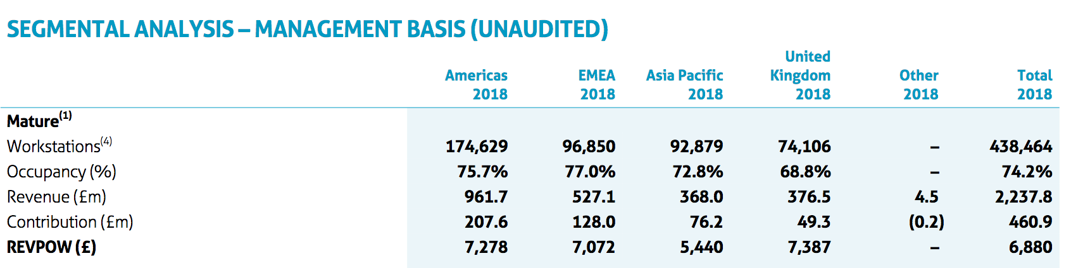

Source: IWG Annual Report 2018

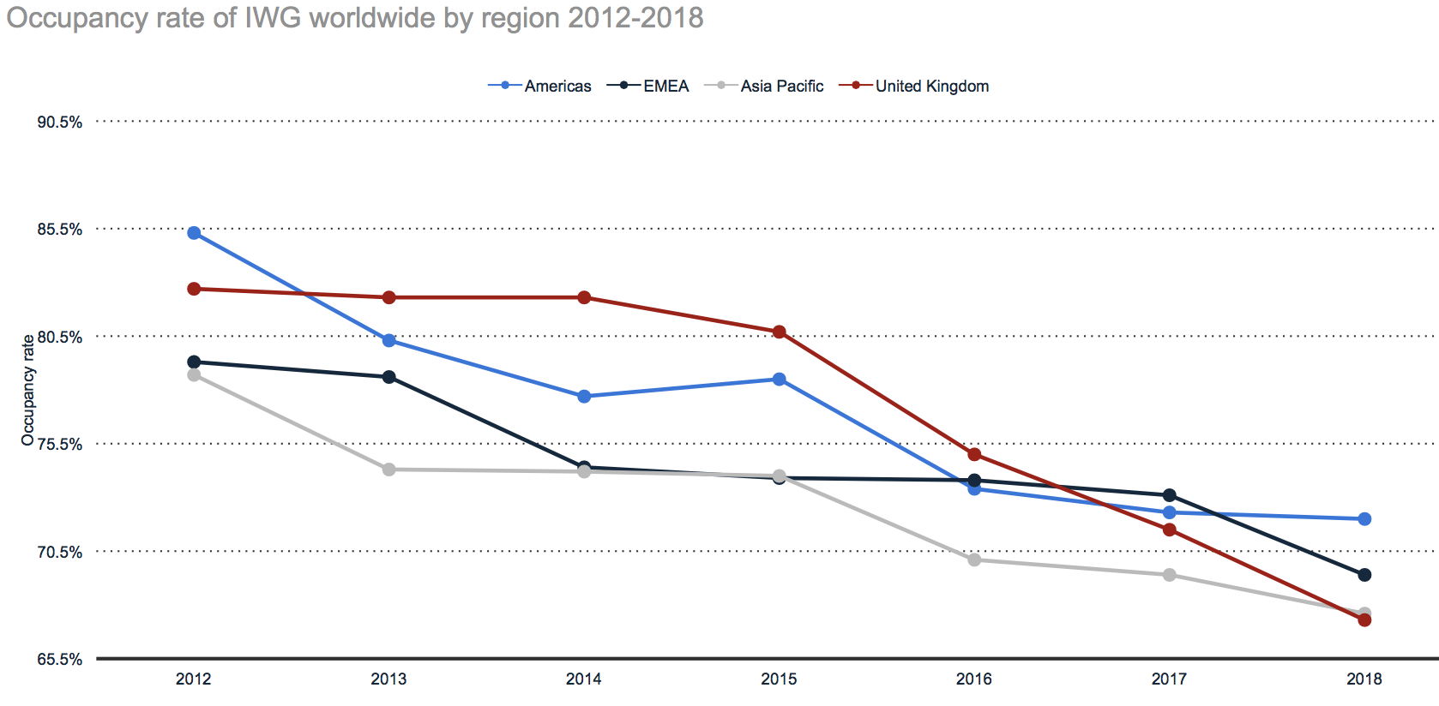

Source: Statista

WeWork says that once a location is mature its occupancy becomes “self-sustaining”, and thus, excludes selling and marketing costs. **This is an unrealistic assumption**.

The S-1 dedicates several pages on its unit economics describing the process of finding, signing, building, filling, and running its workspaces. However, there is little detail on WeWork’s actual business. I would like to know:

* Which expenses are fixed versus variable (as contribution margin only considers variable expenses)
* When do expenses move from one bucket to the other as offices mature
* What is the historical vacancy rate in dollar terms
* What is the membership count per member (i.e., organization)
* Why are all marketing costs excluded in contribution margin
* What are the contract periods for enterprise customers (WeWork signs 15 year leases with landlords but rents out monthly to its customers – think of the Lehman Crises).

Consequently, attempting to build a financial projection model is futile especially considering WeWork’s calculated $3 trillion global TAM (total addressable market). At 14% of U.S. GDP, it’s ridiculous. As of 2019, I calculated the total global coworking space at $15.6Bn using data from Statista (2.2 million coworkers) and average monthly membership of $600.

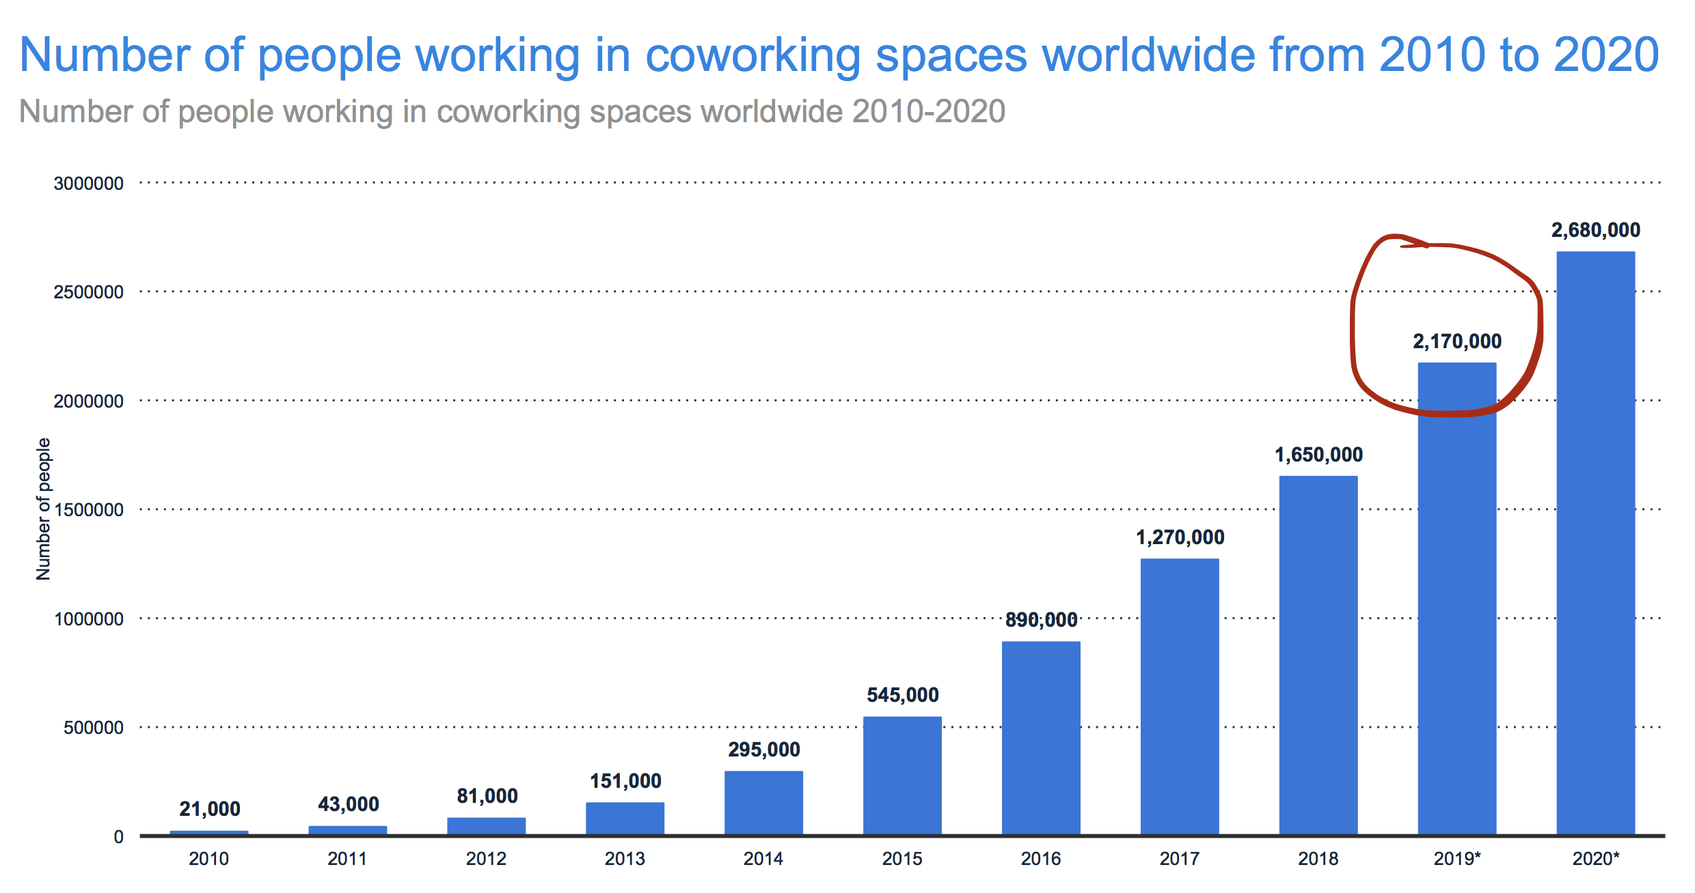

**Section IV: Valuation - What’s WeWork really worth?**

IPOs are typically worth their industry’s revenue multiple (market cap/revenue), plus a premium if there’s rapid growth. The last round’s valuation of $47Bn seems based on the technology industry’s revenue multiple of 15x. The word “technology” appears 123 times in the S-1 and WeWork presents itself as a SaaS (aka cloud software) company which typically benefit from the Network Effect.

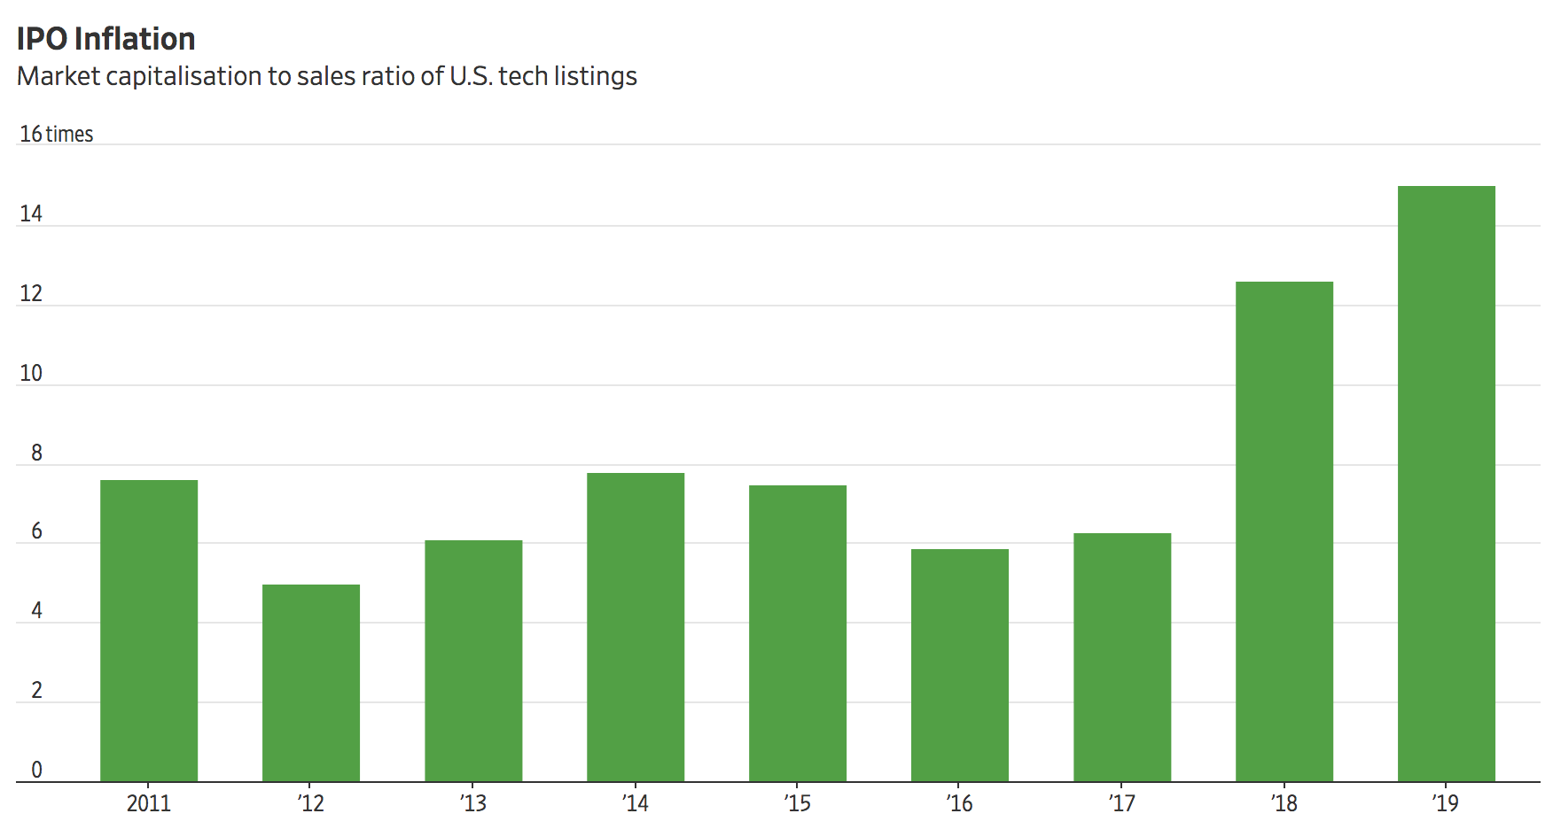

Source: WSJ

I estimate WeWork’s forward revenue of $3.1Bn (based on the June’19 run-rate of $3.3Bn, and $4Bn of committed backlog against management’s expectations for lower average revenue per membership. I believe one could argue WeWork is a real-estate business (e.g., Boston Properties, IWG), but more likely it is a Business Services company. Note that WeWork’s revenues are reported on a gross basis (retailers) not net basis (e.g., Uber, Lyft). As such, the revenue multiple should range from 2-7x. Note that the revenue multiple for all industries is 2.0x and the multiple for business services companies is 1.5x (source: [Professor Damodaran, NYU Stern](http://pages.stern.nyu.edu/~adamodar/New_Home_Page/datacurrent.html)). **Consequently, WeWork should be valued at no more than $20Bn**. Readers must then downwardly adjust for Glassdoor comments and governance issues.

**Conclusion**

*Remember, Adam & the Garden of Eden and Unicorns are just myths!*