**WeWork – Now what?!**

*“God giveth and God taketh away.”*

**Background**

As a reminder, recall that I focus on [socially responsible investing](https://en.wikipedia.org/wiki/Socially_responsible_investing) (SRI), screening for companies that are environmental stewards, treat their employees well and have organizational systems that ensure good governance. A side benefit of SRI/ESG is that it’s a great tool for screening shorts. I never short a stock solely based on valuation, but look for breaches of trust and governance.

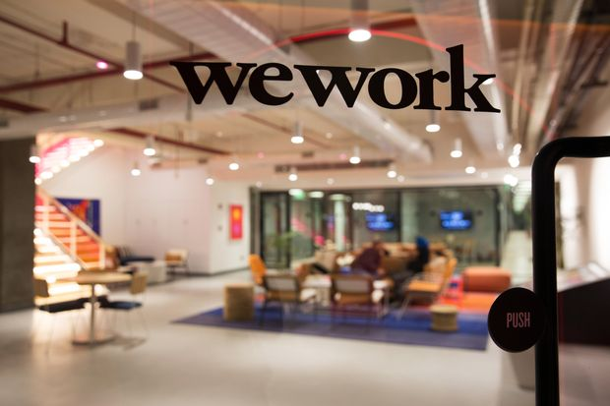

When I published the [original](http://lombardoassetmanagement.org/the-heresy-called-wework/) WeWork article on 9/7/19, the [co-sharing company](https://www.wework.com/mission) was expected to be valued somewhere near its last financing round ($47Bn). In fact, then CFO Artie Minson was shooting for over $50Bn. I valued the company at under $20Bn using purely financial metrics and let you the reader decide a discount for weak ESG. Personally, I had been estimating a $15Bn valuation. The lower valuations were partially attributed to the chart below. EBITDA isn’t supposed to appear as a mirror image to revenues! Amongst a multitude of add-backs, management also adds-back non-cash lease costs which I agree with. This effectively allows rent to be accounted for on an apples-to-apples basis.



Source: We Company, S-1

**Letting the cat out of the bag**

About a month after filing its original S-1 with the SEC on 8/14/19, investors have had enough with the barrage of news over WeWork’s governance and CEO Adam Neumann’s over the top behavior. The final straw was a “recent” revelation about Neumann’s alleged drug use. **Readers of my Idea-article had already been alerted to Neumann’s drug use, as well as the company’s male frat-house culture that encouraged sexual aggression and discrimination based on age, gender & race**. Many of these continue to be un/underreported by the media. The [WSJ](https://www.wsj.com/articles/this-is-not-the-way-everybody-behaves-how-adam-neumanns-over-the-top-style-built-wework-11568823827?mod=hp_lead_pos8) later reported additional Adam muses such as “becoming leader of the world, amassing more than $1 trillion in wealth, and living forever.”

**Behind Adam’s exit**

As of this writing, Adam was forced to step down as CEO and will remain nonexecutive chairman and cede majority share control. His voting control was reduced twice, from 20-1, down to 10-1, and just 3-1 as of 9/25/19. It is said that investor and second largest shareholder Benchmark Capital (Bruce Dunlevie is on WeWork’s board) wasn’t too happy with WeWork’s governance and Adam’s behavior. I saw partner Bill Gurley speaking at a recent Bloomberg conference and was close to asking him about his views but felt it was not respectful given the panel’s focus on sports. Mr. Gurley is well known for being a skeptic of founders’ (whom are often idolized) demands and giving pushback.

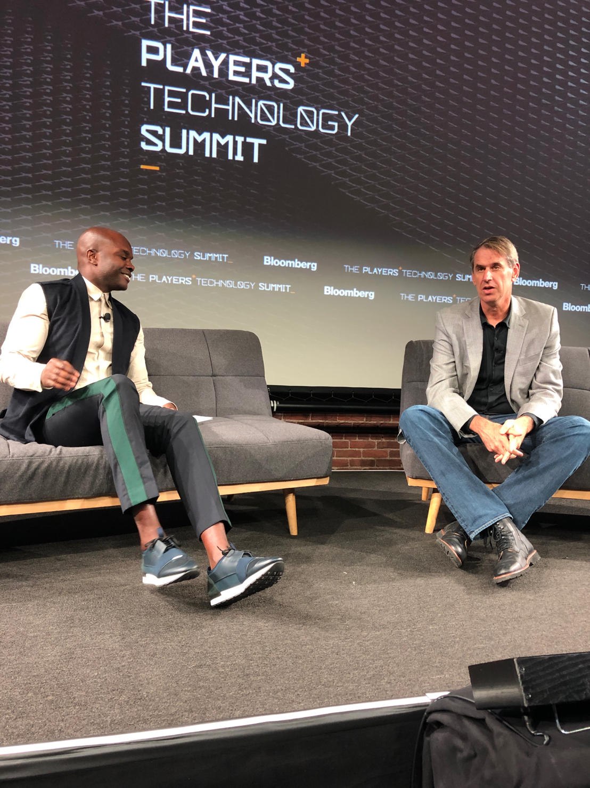

Benchmark’s Gurley (right), Source: Dominic Lombardo

Truth be told, I believe Softbank Group’s Masa was the tipping point that led to Adam’s exit as WeWork has been dependent on Masa Son for much of its recent funding. This IPO feels like a rush-job, meaning they want the IPO to proceed by December before it loses its status as an emerging growth company (reducing red-tape). It is common knowledge that WeWork’s debt funding is contingent on an additional $3Bn (I expect Masa will backstop that) in equity IPO proceeds. WeWork’s in a dire situation and the clock is ticking.

The management changes, in my humble opinion, are too little too late. It’s doubtful that one or two corrective measures will be a panacea. While eccentric, I think readers will agree that Adam was a visionary and charismatic to a fault. Replacing him with two stodgy corporate-types would be a “death from a thousand cuts” as underlying issues remain.

**My prescription to maximize WeWork’s valuation**

I recommend these actions, which will take several months to execute:

* Clean-up the company’s organizational structure, particularly the ARK special purpose entity which tempts self-dealing and other forms of malfeasance.
* Exit all non-core businesses (e.g., WeLive, Rise by We, WeGrow)
* Sell all investments such as the natural foods business and the wave-pool maker
* Remove all traces of nepotism from upper management. Wife Rebecca had run WeGrow.
* Cut significant amounts of staff (this is apparently being [planned](https://www.foxbusiness.com/markets/weworks-next-step-involves-cutting-staff-and-stemming-losses))
* Slow expansion and exit higher vacancy buildings (if even possible)
* Report quarterly key performance indicators that show how mature buildings are performing (this was done in the original [2014 Pitch Deck](https://www.scribd.com/doc/284094314/WeWork-Pitch-Deck))
* Actively consult with Benchmark Capital (they were key to Uber’s shakeup) and hire a real leader (see below)

**While the board’s recent actions look good optically, I believe they do not address WeWork’s underlying toxic culture and egregious governance**. Having Adam return $6MM he received for selling the word “We” just doesn’t cut it. Neumann’s ouster was not the first step in making this company better – it was the **ONLY** step. In a [statement](https://www.wsj.com/articles/for-wework-investor-benchmark-a-struggle-to-balance-board-duties-with-founder-support-11569341467?mod=article_inline), Mr. Neumann said that “We’s business has never been stronger, but that scrutiny directed toward me has become a significant distraction” prompting his decision to step down. Apparently, he still doesn’t get it!

Adam Neumann’s role will be filled by two internal executives as co-CEOs which I consider placeholders: Artie Minson (former co-president and CFO) and Sabastian Gunningham (vice chairman and former Amazon.com executive). Dual-run companies rarely succeed. WeWork needs a charismatic savior in the same light that Dara Khosrowshahi is saving Uber. Because there will be lawsuits and cultures are very difficult to change. WeWork’s “Dara” will need to counterweight all the bad juju that was created. The new company must strive to be the best in corporate social responsibility and swing the pendulum to extreme diversity of gender, race, and age, and with that will arise diversity of thought. The new Dara must move to eliminate the ARK real estate platform.

**The ARK Special Purpose Entity (SPE)**

As a refresher, Adam had owned buildings it was leasing to WeWork which was a conflict of interest. Consequently, ARK was created to purchase Adam’s buildings. This created great optics as the buildings are no longer in Adam’s hands (really?!) and as he constantly reminds, they were “bought at cost.” SPEs are commonly used by corporations especially when dealing with one particular asset such as real estate.

ARK, which was jokingly named after “**A**dam, **R**ebecca and **K**ids” recalls LJM, which was named after Enron CFO’s family. The off-balance-sheet [special purpose entity](https://cma.org.sa/en/Market/SPEs/Pages/default.aspx) is used to purchase buildings that are partially leased to WeWork (**so they’re on both sides of the negotiating table**). While WeWork has committed just 7% of ARK’s $2.9Bn in capital, note it will retain control via the ARK general partner and ARK manager.

I believe if the company did decide to undergo corporate malfeasance, it would do so using ARK. The entity could be used to remove liabilities from WeWork’s balance sheet onto ARK. This is because WeWork would not have to consolidate ARK’s balance sheet. Further, WeWork could also shift the landlords it leases from towards those buildings owned by ARK. It could then agree to more favorable long-term leases with buildings owned and managed by ARK and therefore letting losses arise within ARK. Remember, WeWork is not required to consolidate ARK onto its balance sheet – though WeWork will eventually be responsible for ARK’s debt.

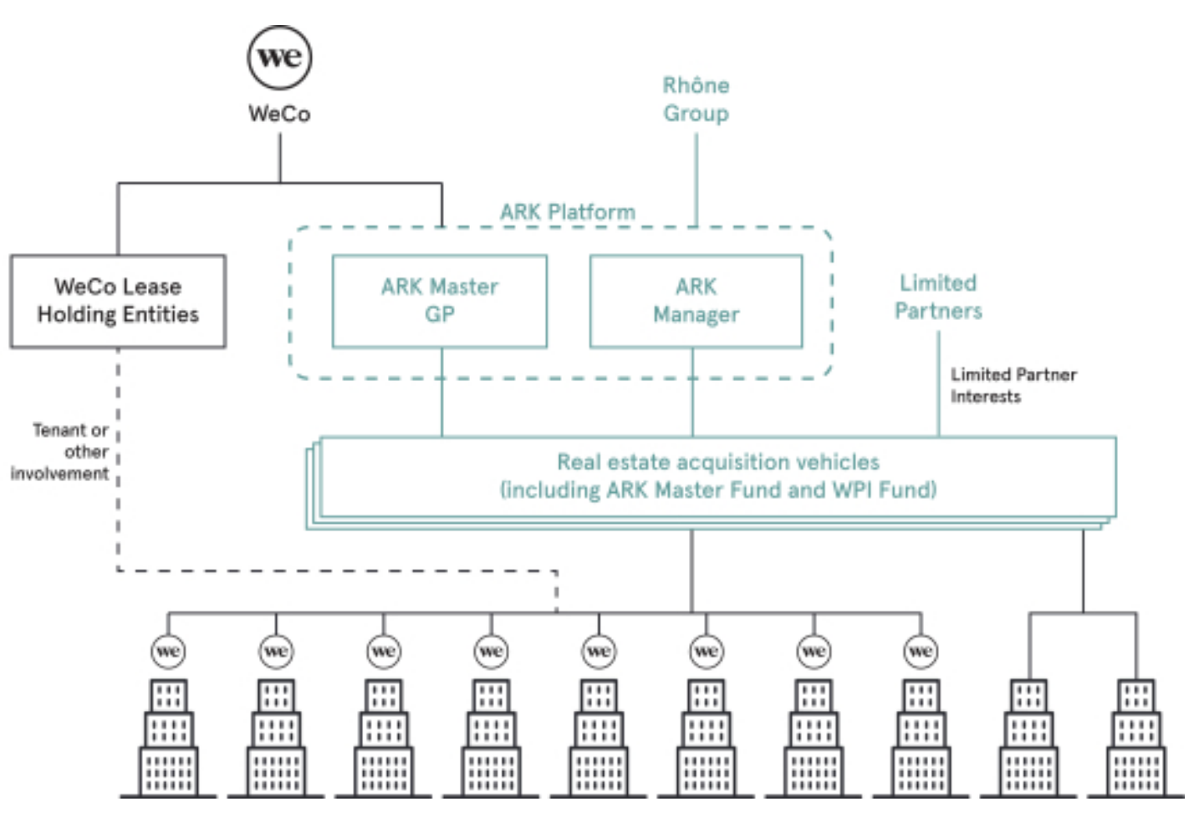

**Conclusion**

Adam Neumann has also [joked](https://qz.com/1687307/wework-ceo-adam-neumanns-weirdly-close-relationship-with-the-company/) that ARK is a reference to Noah’s Ark – the ship that saved him. Perhaps Adam was right? Given that the hourglass is ticking, I expect WeWork to do a rush job and get the IPO done by year-end. I think this will be a mistake as it does NOT address underlying issues of weak governance and the toxic DNA embedded throughout the organization.